JAVA DAY - 15

TASK - 5  
  
1. Write a program using map() method, to convert a list of Strings into uppercase. If the given List is: Stream names = Stream.of("aBc", "d", "ef");

Input -

package task.five.one;

import java.util.stream.Stream;

public class ToUpperCase {

public static void main(String[] args) {

Stream<String> names = Stream.*of*("aBc", "d", "ef");

Stream<String> upperNames = names.map(String::toUpperCase);

upperNames.forEach(System.*out*::println);

}

}

Output -

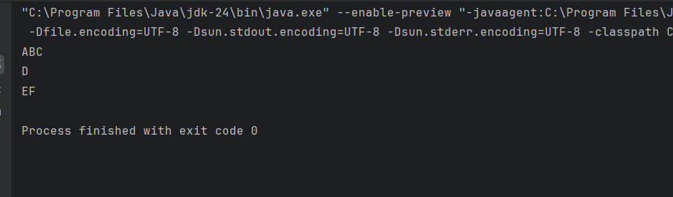

2.Write a program to check whether the Strings in the List are empty or not and print the list having non-empty strings. If the given List is: Liststrings = Arrays.asList("abc", "", "bc", "efg", "abcd","", "jkl");

Input -

package task.five.two;

import java.util.Arrays;

import java.util.List;

import java.util.stream.Collectors;

public class NonEmptyStrings {

public static void main(String[] args) {

List<String> strings = Arrays.*asList*("abc", "", "bc", "efg", "abcd", "", "jkl");

List<String> nonEmptyStrings = strings.stream()

.filter(s -> !s.isEmpty())

.collect(Collectors.*toList*());

System.*out*.println("Non-empty strings: " + nonEmptyStrings);

}

}

Output-   
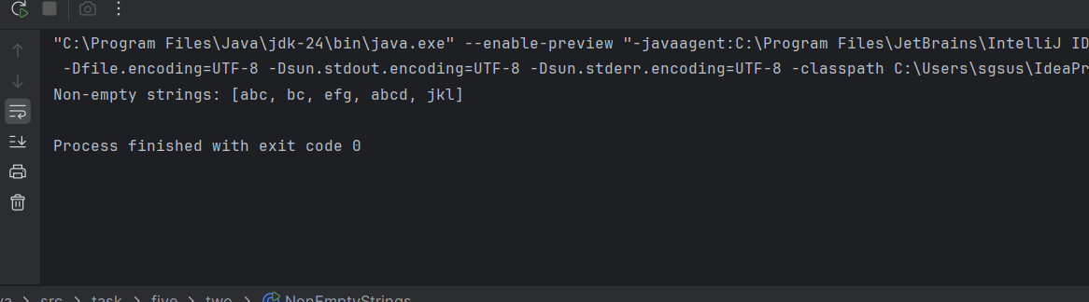

3.You are a teacher in school .In your class there are 10 students, you have decided to give special gifts to those students whose names start with "A".you are asked to separate those students with the help of a java program.

Requirement:

Use List interface to store the student name

Use a lambda expression and the Stream API to filter the students.

Input -

package task.five.three;

import java.util.Arrays;

import java.util.List;

import java.util.stream.Collectors;

public class FilterStudentsByName {

public static void main(String[] args) {

List<String> students = Arrays.*asList*(

"Sue", "Joe", "Anny", "Amala", "John",

"Xaviour", "Anoop", "Nandhu", "Lily", "Sara"

);

List<String> specialGiftStudents = students.stream()

.filter(name -> name.startsWith("A"))

.collect(Collectors.*toList*());

System.*out*.println("Students receiving special gifts are:");

specialGiftStudents.forEach(System.*out*::println);

}

}

Output -

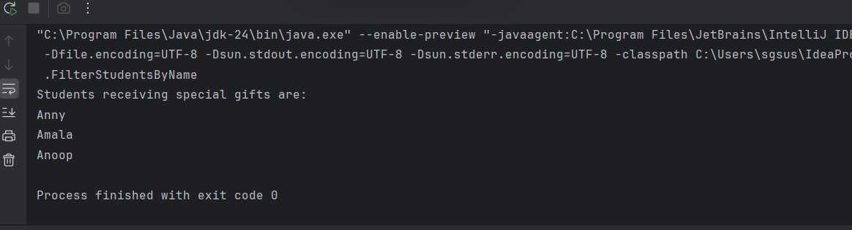

4.Rajesh has been given a task to create an app which takes the user's birthdate as input and calculates their age you have to help him to build this app using the java.time.LocalDate class.

Input:

Enter your birthdate (yyyy-mm-dd): 1990-05-15

Output:

Your age is: 33 years, 4 months, and 13 days.

Input-   
  
package task.five.four;

import java.time.LocalDate;

import java.time.Period;

import java.util.Scanner;

public class AgeCalculatorApp {

public static void main(String[] args) {

Scanner scanner = new Scanner(System.*in*);

System.*out*.print("Enter your Birthdate (yyyy-mm-dd): ");

String input = scanner.nextLine();

try {

LocalDate birthDate = LocalDate.*parse*(input);

LocalDate currentDate = LocalDate.*now*();

if (birthDate.isAfter(currentDate)) {

System.*out*.println("Not a valid Birthdate.");

} else {

Period age = Period.*between*(birthDate, currentDate);

System.*out*.println("Your age is: " +

age.getYears() + " years, " +

age.getMonths() + " months, and " +

age.getDays() + " days.");

}

} catch (Exception e) {

System.*out*.println("Invalid date format. Please enter in yyyy-mm-dd format.");

}

}

}

Output -  
